Consultation document for Fairtrade Stakeholders
Review of Fairtrade Standard for Flowers and Plants with focus on wage improvement towards Living Wages

Consultation Period | 17June – 17 July 2024
Project Manager | Jebet Winnie Yegon, Project Manager, Standards  j.yegon@fairtrade.net

PART 1 – Introduction

1. General Introduction to the standards review project
Fairtrade Standards support the sustainable development of small-scale producers and workers in the Global South. Producers and traders must meet the relevant Fairtrade Standards for their products to be certified as Fairtrade. Fairtrade International’s Standards and Pricing Unit (S&P) is responsible for developing Fairtrade Standards in line with the Standard Operating Procedure for the Development of Fairtrade Standards and in compliance with all requirements of the ISEAL Code of Good Practice for Setting Social and Environmental Standards. A fundamental principle is wide consultation with stakeholders to ensure that new and revised Standards reflect Fairtrade International’s strategic objectives, are based on producers’ and traders’ realities and meet consumers’ expectations.
The deadline for completing the survey is 17 July 2024. If you have any further comments, please send them to standards-pricing@fairtrade.net.
Following the initial consultation, S&P will compile and aggregate all the comments received and share them anonymously via email and on the Fairtrade International website.

2. Background
“Everyone who works has the right to just and favourable remuneration ensuring for himself (or herself) and his (or her) family an existence worthy of human dignity.”
United Nations’ Universal Declaration of Human Rights, 1948 (Article 23.3)
A Living Wage (LW) is defined by the Global Living Wage Coalition as the remuneration received for a standard work week by a worker in a particular place sufficient to afford a decent standard of living for the worker and her or his family. Elements of a decent standard of living include food, water, housing, education, health care, transport, clothing, and other essential needs, including provision for unexpected events.

Report of ILO Committee of Experts, March 2024, adopted by the ILO Governing Body:
The concept of a living wage is consistent with the International Covenant on Economic, Social and Cultural Rights (The Covenant) and the United Nations Universal Declaration of Human Rights (UDHR). The Covenant and the UDHR are internationally recognized human rights instruments. In line with the UN Guiding Principles on Business and Human Rights and the ILO Tripartite Declaration of Principles Concerning Multinational Enterprises and Social Policy (MNE Declaration), States have an obligation to protect human rights; and all enterprises, regardless of their size, sector, operational context, ownership and structure, should respect human rights throughout their operations.
EU Corporate Sustainability Due Diligence Directive:
Annex:
The right to enjoy just and favourable conditions of work, including a fair wage and an adequate living wage for employed workers and an adequate living income for self-employed workers and smallholders, which they earn in return from their work and production, a decent living, safe and healthy working conditions and reasonable limitation of working hours, interpreted in line with Article 7 and 11 of the International Covenant on Economic, Social and Cultural Rights;
Recitals 34 and 39:
Where relevant, companies should adapt business plans, overall strategies and operations, including purchasing practices, and develop and use purchase policies that contribute to living wages and incomes for their suppliers, and that do not encourage potential adverse impacts on human rights or the environment.
Wages are the main factor determining the livelihoods of workers and, while they have increased globally over the years, in many regions and countries workers’ wages are still below a living wage. Inadequate wages are linked to weak labour rights and precarious labour conditions including modern slavery, and in response various countries are legislating to strengthen human rights due diligence in the supply chain.
Fairtrade shares a vision of a world in which justice and sustainable development are at the heart of trade structures and practices so that everyone, through their work, can maintain a decent and dignified livelihood and develop their full human potential.
In the long term a living wage is the best way to ensure workers can provide for their families and save some money for emergencies. The right to a living wage is enshrined in the International Bill of Rights and is recognized as a major contributor to achieving several of the UN’s Sustainable Development Goals, including the number one goal to eradicate poverty. The EU Human Rights and Environmental Due Diligence law (HREDD) through the European Corporate Sustainability Due Diligence Directive (CSDDD) and national legislation requires companies to take responsibility down their supply chains for human rights associated with products sourced.
One of the key priorities for Fairtrade and part of its strategy is to close the gap between the actual wages and the relevant living wage benchmark (LWB). The proposal presented in this consultation is to reduce this gap step by step because Fairtrade acknowledges that fully closing this gap depends on the commitment and collaboration between different actors across the supply chain over the long term.
The main avenue to support wage improvement is through the promotion of freedom of association and the effective recognition of the right to collective bargaining. Fairtrade tools used to support more value from the supply chain to benefit workers should not be misused to undermine trade union rights or circumvent collective bargaining on wages. In alignment with the International Labour Organisation, Fairtrade considers collective bargaining combined with adequate minimum wages regulated by governments the best means for workers to improve their wages as legal entitlements.
Until workers and employers have sufficient resources to raise negotiated wages to Living Wage levels, supply chain contributions can help workers meet essential needs for themselves and their families. Therefore, Fairtrade has identified two tools to support worker incomes on Fairtrade flower plantations:
- Fairtrade Premium contribution. A proportion of the Fairtrade Premium is paid in cash to workers. This should not be considered as a wage, but cash payments or other individual disbursements from premium funds that can supplement household incomes until a living wage is reached.
- Living Wage Differential (LWD). The Living Wage Differential is paid by the supply chain in countries where the remuneration is below the Living Wage. It aims to increase remuneration in countries where the gaps are relatively large. It is paid on the basis of Fairtrade sales and cannot be considered as a wage, but as a bonus.
Fairtrade therefore proposes that remuneration should be raised if it falls below the living wage benchmarks as approved by Fairtrade International. In the short term, the Fairtrade Premium and additional LWD can help workers and their families until the living wage gap is closed. The remaining gap to a living wage will be closed through regularly adjusted adequate minimum wages complemented by collectively negotiated wage rates based on sound industrial relations.
This multi-pronged strategy has been widely discussed and approved in the Fairtrade system. If you have other proposals how to reduce or close the living wage gap, please let us know as feedback to this consultation.
To better understand how living wage benchmarks are calculated please visit the Global Living Wage Coalition page.
Fairtrade’s strategy for fairer wages in floriculture
Fairtrade Floor Wage
In 2017, Fairtrade introduced a requirement in the flower and plant standard that workers are paid a minimum of $1.90/day PPP (World Bank extreme poverty line). The floor wage was further increased to $2.15/day PPP in April 2023, following the update of the World Bank poverty line in September 2022.
The Fairtrade floor wage is set at the World Bank extreme poverty line and is updated based on inflation. Please see the explanatory document on how to calculate floor wages in the Fairtrade Standard for Flowers and Plants for more information.
Living wage benchmarking 2022
In 2023, Fairtrade conducted a data collection and analysis exercise to determine the gap between the actual remuneration of flower workers and the living wage in their region or country using the IDH Salary Wage Matrix. This analysis was completed on 14 farms across four countries in East and Southern Africa. The calculated remuneration included basic wage, in-kind benefits, cash allowances and bonus payments. The value of the received in-kind benefits should not exceed 30% of the total remuneration (see Anker & Anker. 2017. Living wages around the world). The analysis found that 72 percent of workers received wages that were lower than 50 percent of the living wages benchmark for their regions.
To be able to collect more robust wage data in a standardised way, Fairtrade has introduced a requirement on mandatory wage reporting (See requirement 3.2.2 of the Fairtrade Standard for Flowers and Plants).This requirement will be applicable as of April 2025.
A pre-consultation meeting held with workers from seven flower farms in Kenya in May 2024 confirmed the output of the analysis that workers are seeing a significant shortfall in wages. They reported they would need approximately KSh10,000 (c. €70) more in monthly wages to cover their living expenses. They also indicated that receiving a higher percentage of the Fairtrade Premium as a cash bonus could be seen as complementary to trade union negotiations.

3. Objectives of the Standards Review
- Develop a framework for Fairtrade flower origins to move towards living wages.
- Engage stakeholders to ensure they clearly understand the proposal.
- Consult with relevant stakeholders on the proposal (and possible alternatives).
- Develop a proposal for consultation and recommendations to the Standards Committee (SC) considering two tools: distribution of the Fairtrade Premium in cash and the Living Wage Differential.

4. Project and Process Information
The project started in April 2023 with the launch of the project assignment which is available on the Fairtrade International website. Please see the project timelines below:
Activity | Timeline
Scoping | April 2023
Research | May 2023 – May 2024
Pre consultation (only for workers by FTA) | May 2024
Public Consultation | 17 June – 17July 2024
Drafting final proposal | August 2024
SC decision | September 2024
Publication | Q1 2025

5. Confidentiality
We value your input and will analyse all responses carefully to inform the final proposal. All information will be treated with care and confidentiality, and the results will only be communicated in aggregated form. In order to make the best use of the data, we do need to know which responses are from producers, traders, licensees, etc., so we kindly ask you to provide us with information about your organisation.

6. Acronyms and definitions
Acronyms:
CLAC The Latin American and Caribbean Network of Fairtrade Small Producers and Workers
CSDDD Corporate Sustainability Due Diligence Directive
FP Fairtrade Premium
FPC Fairtrade Premium Committee
FTA Fairtrade Africa
GLWC Global Living Wage Coalition
HL Hired Labour
HREDD Human Rights Environmental Due Diligence
IDH Sustainable Trade Initiative (based in Utrecht, The Netherlands)
IKB In-kind benefits
LW Living Wage
LWB Living wage Benchmark
LWD Living Wage Differential
NAPP The Fairtrade Network of Producers in Asia Pacific region
NFO National Fairtrade Organisation
PN Producer Network
SC Standards Committee
S&P Standards and Pricing Unit
Definitions:
Basic wage is the minimum fixed amount of money which a worker is entitled to be paid by his/her employer. It excludes the additional benefits like bonuses, allowances, or any such compensation.
Floor wage relates only to the gross wage, therefore in-kind benefits cannot be counted. Cash allowances issued regularly to all workers as an entitlement and allowing workers full discretion on how to spend the money without a link to the attendance or performance of workers, count towards the floor wage.
In-kind benefits (IKB) are non-monetary benefits that are provided to workers by their employer.
Living wage (LW) is defined by the Global Living Wage Coalition as the remuneration received for a standard work week by a worker in a particular place sufficient to afford a decent standard of living for the worker and her or his family. Elements of a decent standard of living include food, water, housing, education, health care, transport, clothing, and other essential needs, including provision for unexpected events.
Living Wage Differential (LWD) is defined as the amount to be paid by the supply chain (per flower stem) to move remuneration towards the living wage for that region. It is calculated as follows: LWD = Living Wage minus Average Remuneration minus Contribution from the Fairtrade Premium
Living wage gap is the difference between the remuneration a worker receives and the living wage benchmark applicable for the region or country where the company is located.
Premium Vouchers are defined as coupons given to workers when cash disbursements from the Fairtrade Premium are heavily taxed (being a non-advantageous option to workers).
Remuneration is the total financial value that includes all forms of pay (basic wage, cash allowances, bonuses, and in-kind benefits) that the worker receives in a specific period.
Workers are defined as all workers including migrant, temporary, seasonal, sub-contracted and permanent workers. ‘Workers’ is not limited to field workers but includes all hired labour personnel, such as employees working in the company’s administration. The term is restricted to personnel that can be unionised and therefore normally excludes middle and senior management. However, in Kenya, workers also include Supervisors who in the organisation’s hierarchy come immediately after/above the general worker (lowest grade supervisor, junior supervisor, senior supervisor) and no other higher-level management.

7. Background information to the consultation proposals
Fairtrade living wage strategy for floriculture
Fairtrade has developed a concept for consultation with our stakeholders to realize Fairtrade living wage contributions on flower farms. The concept relies on a contribution from the Fairtrade Premium and a contribution from the supply chain for the Fairtrade flowers.
Fairtrade acknowledges that the current wage gap is too large for producers to reduce by themselves, and we recognize that on average, Fairtrade flower farms sell only 20% of their production under Fairtrade terms. It is therefore proposed that only for the volumes sold as Fairtrade, a Fairtrade Living Wage Differential (LWD) would be paid by the supply chain (see Figure 1).
As a result of the proportion sold as Fairtrade, the potential to close living wage gaps is limited. We acknowledge the need for a wider sectoral approach going forward and we encourage the industry, retail, other standard setters and NGOs to join us and identify ways to improve wages on flower farms.
The data collection and analysis conducted by Fairtrade International in 2023 showed the average gap between current wage paid and the LW is on average approximately €0.0015 per stem once a contribution from the Fairtrade Premium is taken into account. This is based on farms selling 100% of their production under Fairtrade terms.
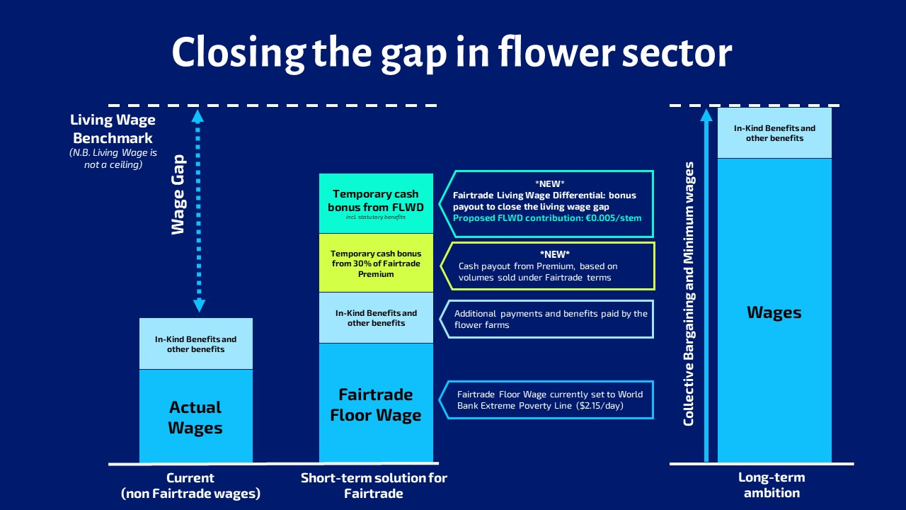
Figure 1 Model of remuneration with Fairtrade LWD and Premium bonus
Considering that the gap is too large to reduce in one go therefore a gradual approach to reduce the wage gap is required. Initially approximately one third of the gap will be reduced by a supply chain contribution from retailer/trader, this equates to a payment of €0.005 per stem. This amount would apply in all countries worldwide where there is a living wage gap.
Step by step approach
Once this proposal is introduced, any subsequent steps will be to assess the effects and the impact of the introducing LWD every 3 years (potentially in 2027/28 and 2030/31). Only after a consultation process would any further steps be taken to increase the LWD (see Figure 2).
No further targets of contribution are proposed during this consultation, and the subsequent stages will be consulted once stage one is fully implemented, and a monitoring review completed.
Fairtrade strives for wage improvement as a result of collective bargaining and aims for the payment of living wage differentials to be reflected in collective bargaining agreements, either as a bonus or a regular wage increment. Collective bargaining being the only sustainable way to set wages that are contractual entitlements (which workers can take to “the bank”). Although there is collective bargaining in several origins for Fairtrade flowers that process has mixed results, due to a combination of weak regulation and workers’ rights protection, and in some cases, an apparent lack of good faith bargaining shown by employers. At times, Fairtrade’s floor wage requirement has been used as a reason to refuse negotiating wage rates for workers earning more than the floor wage but less than the living wage. Also, some employers have proposed to their trade union counterpart to set basic wage rates below the Fairtrade Floor Wage, which would cause the position of the trade union among workers to be undermined. Therefore during this consultation, we also seek to strengthen our standards to promote good faith bargaining, especially on wages for workers that do not earn a living wage. To that end, Fairtrade will work with producers, traders, and retailers and also involve trade unions and industry organisations such as the Kenya Floriculture Council (KFC), the Ethiopian Horticulture Producer Exporters Association (EHPEA), as well as the Sustainable Trade Initiative (IDH) and the Floriculture Sustainability Initiative (FSI) in the discussions on the design and implementation of our strategy.
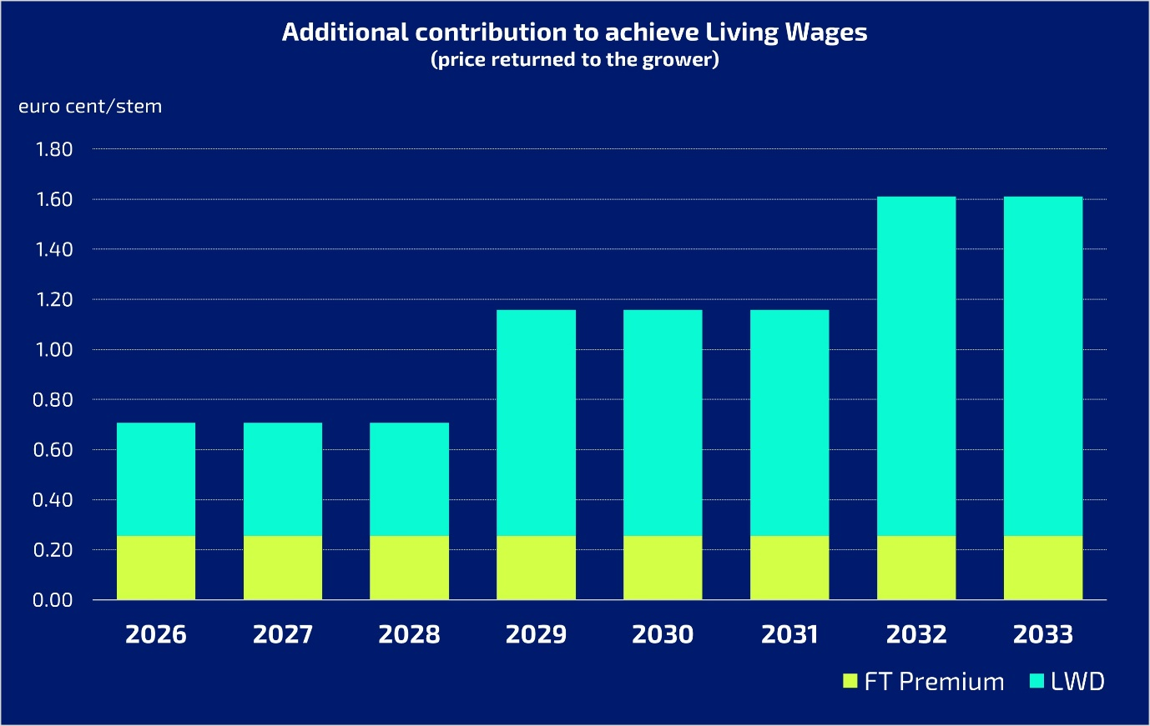
Figure 2 Illustrative example of the step by step approach to progress towards a living wage, assuming a fixed Fairtrade Premium contribution and the recalculation of the LWD after three and six years
Verification
It is proposed that the living wage differential is paid to the producer company and is shown in the wage slip for each worker to have full visibility. FLOCERT will verify that the amounts paid by the supply chain does reach the workers in the correct amounts.
Parts of remuneration contributions
Fairtrade Premium Contribution
A contribution from the Fairtrade Premium (at a maximum of 30% of the premium) would be made in cash to workers whilst remuneration are below the LW. This is in addition to the optional distribution of Fairtrade Premium to workers of 20% that is stipulated in requirement 2.1.20 in the Hired Labour Standard.
Living wage differential
The Fairtrade Living Wage Differential (LWD) is set as a figure per stem to increase worker remuneration where this is below the living wage. The contribution towards the LWD will be the same for all countries in the first instance where remuneration is below the living wage.
The requirement is complementary to the existing Requirement 3.5.4 in the Hired Labour Standard on Wage Level Increase.
Why do we propose 0.5 euro cents/ stem?
As mentioned in the General Introduction, living wage (LW) gaps were calculated by subtracting the total remuneration (basic wage + cash allowances/bonuses + in-kind benefits) from the living wage benchmark (LWB). Special attention was given that in-kind benefits did not exceed 30% of the total remuneration. Based on the number of workers earning below a living wage, the size of the LW gap and the annual production of the farm, we calculated the additional price per flower stem that will be required to increase the wage of all workers and reach the LWB of the country. Important to note that the price increase does not consider any additional labour costs incurred, e.g. levies and/or taxes.
Please find in Table 1 the average price increase needed to close the LW gap in each country. The proposed LWD of 0.5 euro cent per stem reduces approximately one third of the living wage gap.
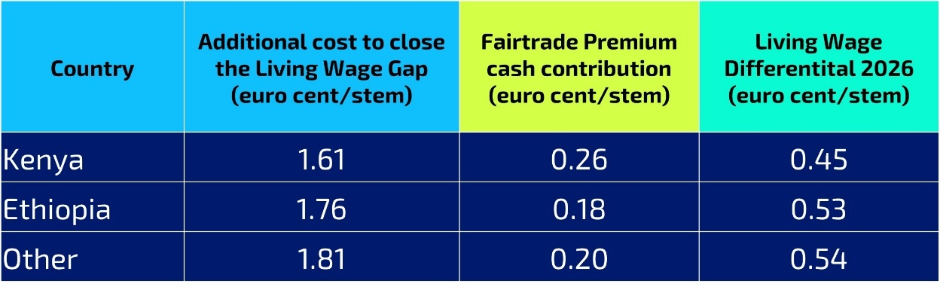
Table 1 Average contribution (in euro cent per stem) required to close the living wage gap in the different countries

PART 2 Draft Standard Consultation
This consultation is divided into the following sections:
0. Information about your organisation 11
1. Partial distribution of Fairtrade Premium as cash 12
2. Fairtrade Living Wage Differential 16
3. Promoting collective bargaining and trade union rights and clarification of the floor wage requirement 19
4. Stakeholders’ comments/feedback on the present consultation 21
The target groups of this consultation are:
- Workers and worker representatives of certified producer organisations.
- Trader unions representing workers in Fairtrade certified organisations.
- Flower producers already certified or interested in becoming certified under the Fairtrade Standard for Flowers and Plants for Hired labour.
- Licensees and traders certified or interested in becoming certified under the Fairtrade Standard for Hired Labour Organisations.
- Producer Networks (PNs), National Fairtrade Organisations (NFOs), Fairtrade International, FLOCERT, NGOs, consumers, researchers, etc.
Please answer each question whereby stakeholders are invited to comment on the description of the topic and to share their views on the question. Stakeholders are also invited to suggest additional ideas to address the topic and proposals to close or reduce the living wage gap.
During the consultation, Standards and Pricing (S&P) together with Producers Networks at Fairtrade Africa (FTA), CLAC in Latin America/Caribbean and NAPP in Asia might conduct separate workshops with workers and plantation management to discuss the topics in this questionnaire. Workshops will depend on the local situation.
The amount of time you spend answering the questionnaire will depend on how detailed your answers are. Your input is very important, so please take your time.
Please note that workers are also being consulted regarding the distribution and use of the Fairtrade Premium.
Please take as much space as you need to respond to the questions.

Information about your organisation
Please complete the information below:
Q 0.1 Please provide us with information about your organisation so that we can analyse the data precisely and contact you for clarifications if needed.
The results of the survey will only be presented in an aggregated form and all respondents’ information will be kept confidential.
Name of your organisation
Name of contact person
Email of contact person
Country
FLO ID (if any)
Q 0.2 What is your responsibility in the supply chain? Please tick all that apply.
Worker
Producer
Trade union or workers’ organisation
Exporter
Importer
Processor
Retailer
Licensee
Other (e.g. CLAC, FTA, NFO, FLOCERT, Fairtrade International, researchers, NGO, consumer)
If other, please specify here:

Partial distribution of Fairtrade Premium as cash
The proposal aims to:
Introduce a set allocation of a percentage of the Fairtrade Premium to be disbursed as cash (or in-kind) to workers as an additional contribution towards achieving a living wage. This is in addition to the optional distribution of Fairtrade Premium to workers of 20% that is stipulated in requirement 2.1.20 in the Hired Labour Standard. This would reduce the wage gap, proportionally to Fairtrade sales, where the remuneration is below the living wage.
The proposed change is:
1.1 To allocate a percentage of the Fairtrade Premium to workers as cash on Fairtrade flower plantations as long as living wages have not yet been reached.
Applies to: Companies
Core | As long as there is a gap between the living wage and the remuneration received by workers, a maximum of 30 percent of the Fairtrade Premium is equitably disbursed in cash or in-kind, only among workers that earn less than the living wage, in accordance with the time worked, as a Fairtrade Bonus until the living wage gap is closed.  Payments are made in cash or premium vouchers of equal value to cash disbursements may be disbursed in those origins where payment in cash is not an advantageous option.  Your company demonstrates the transparency and accuracy of the payments made by the Fairtrade Premium Committee according to the rules described in this requirement.  Your company ensures that no benefits are worsened/reduced after the introduction of this requirement except when formally agreed with elected worker representatives who have the right to negotiate.
Year 1
Guidance:
If the gap between the lowest remuneration and the living wage can be bridged using less than 30 percent of the Fairtrade Premium, the percentage for mandatory payout needs to be reduced accordingly.
In addition to the disbursement of 30 percent of the Fairtrade Premium, the option to disburse 20 percent of Premium funds in cash remains (see Requirement 2.1.20 of the Hired Labour Standard). Consequently, workers could disburse up to 50 percent of the Premium in cash if they so choose.
Premium vouchers may be disbursed in cases where the disbursement in cash is not an advantageous option - for example, where disbursing the Premium in cash could result in high tax payments. Premium vouchers can be used for essential needs that contribute to a decent livelihood, such as: home construction or renovation, education fees, and regular household items.
The nature and frequency of disbursements must be consulted upon with local trade unions or in their absence with other elected worker representatives, to ensure that collective bargaining is not undermined.
Premium vouchers cannot be used for:
- Goods or services which companies are required to provide by law, by Fairtrade Standards or by collective bargaining agreements, or to those customarily provided by the company
- Visas or work permits for migrant workers
- Clothing or equipment for work
- Dormitories or shared housing for seasonal workers
- Drinking water
- Land for kitchen gardens
- Charitable contributions to the community that do not go exclusively to workers
- Employers’ contributions to social security
- Time off work for vacations; sick leave or maternity leave
- Other non-statutory expenses provided continuously, such as work meals and transport to and from work, childcare, etc.

Rationale:
A set Fairtrade Premium contribution will support in improving remuneration for workers, therefore making progress towards the living wage benchmark. The proposal is that a maximum percentage of the Fairtrade Premium – beyond the 20% already possible - will be used individually by workers to meet essential needs. It is important to mention that the Fairtrade Premium cash contribution is not considered as part of the wage paid by the company, but as a bonus paid by other stakeholders in the value chain and varies according to Fairtrade sales.
The use of the Fairtrade Premium in cash to help reduce the living wage gap is a temporary measure until the remuneration received reaches the living wage benchmark level.
To avoid confusion with wages, and since the Premium depends on Fairtrade sales that vary from week to week, Premium cash disbursement should only happen occasionally during the year. A suggestion provided during the pre-consultation with workers in Kenya was that the premium cash disbursements can be distributed on a quarterly basis.
It is suggested that the Fairtrade Premium Committee (FPC) could contract the company to pay this cash amount via the payroll system so that any taxes or deductions can be paid and for the purpose of transparency.
Premium vouchers must be of an equivalent value of the Premium disbursed in cash and can be only used in cases where the disbursement in cash is not worthy, for example, when very high tax restrictions are imposed on Premium payments that are distributed as cash.
Premium vouchers should not be provided to cover costs that the companies are required to meet by law, Fairtrade Standards or collective bargaining agreements; or those that are provided continuously (such as work meals, childcare or transport from and to work).
Implications:
The Fairtrade Premium Committee need to calculate the 30% of the total Premium received in a chosen period and allocate this towards starting to reduce the living wage gap. The FPC would allocate these as cash or in-kind to be received equitably and in accordance with time worked among workers.
In case 30% of Premium is more than what is needed to reduce the wage gap, then only the required percentage of the Premium should be used. The Fairtrade Premium Committee will disburse this amount as agreed in the General Assembly. It is expected that this premium contribution would be passed to the certified producer for distribution via the pay slip with the workers’ wages, thus permitting any associated taxes to be deducted. Written reports and transparent recording is required.
The implementation of this change requires capacity building with the companies, and particularly with the Fairtrade Premium Committee, not only to ensure the transparency and accountability of the Fairtrade Premium but also to strengthen the decision-making processes of the Fairtrade Premium Committee and the workers in relation to their Fairtrade Premium investments (e.g. investments of Premium funds as a bonus pending the achievement of a living wage vis-à-vis other investments for collective projects).
If paid as cash any additional taxes or social security costs would be paid from the premium contribution and not from the company.
Q 1.1 Do you agree that as of 1st January 2026, As long as there is a gap between the living wage and the lowest gross wage received by workers, a maximum of 30 percent of the Fairtrade Premium is equitably disbursed in cash/in-kind, only among the workers that earn less than the living wage, in accordance with the time worked, as a Fairtrade Bonus until the living wage gap is closed?
Note: the 30 percent is to be used in addition to Requirement 2.1.20 in the Hired Labour Standard that allows workers – if they so choose – to distribute 20 percent of the Fairtrade Premium in cash. Depending on local tax rules, workers may choose to receive the Premium bonus in vouchers, instead of cash.
Agree
Disagree
Undecided
If you disagree, please suggest an alternative proposal
Q 1.2 Do you agree that this requirement applies to the Premium received from Fairtrade sales as of 1st of January 2026 onwards? This requirement does not apply to Fairtrade premium from 2025 received in 2026 and any savings from the Fairtrade premium from 2025.
Agree
Disagree
Undecided
If you disagree, please suggest an alternative proposal
Q 1.3 Do you agree that the premium contribution should be paid as cash via the pay slip noting that some tax may be deducted?
Agree
Disagree
Undecided
If you disagree, please suggest an alternative proposal
QUESTIONS FOR WORKERS ONLY
Q 1.4 Has cash or in-kind benefits from the current Fairtrade premium impacted your well-being as a worker?
Yes
No
Undecided
because
Q 1.5 Do you agree with the proposed requirement that an additional 30% of Fairtrade premium should be allocated to workers as in-kind or cash?
Agree
Disagree
Undecided
because
Q 1.6 Would you prefer the additional 30% premium is allocated quarterly to workers as cash or in-kind benefits (like food vouchers, mattresses, etc.)? Why?
Cash
In-kind
because

Fairtrade Living Wage Differential
The proposal aims to:
Set the Fairtrade Living Wage Differential at 0.5 euro cent per stem for cut flowers only. This is to be paid to workers as bonus on a quarterly basis. The intention is to increase workers’ income while contributing to a decent standard of living for workers and their families and reducing the Living Wage gap.
The proposed change is:
2.1 To introduce a Fairtrade Living Wage Differential for Fairtrade cut flowers
Applies to: Traders of cut flower (does not apply to filler, plant or bulb products)
Core | Traders pay 0.5 euro cent/stem in addition to the commercial purchase price to the producer as a Living Wage Differential if the remuneration for workers are below the living wage for that country/region.  This is paid on a quarterly basis (for stems sold in the previous quarter) and is to be paid within one month after the end of the quarter.  You ensure that no benefits have been worsened/reduced after the introduction of this requirement.
Year 0
Guidance: Fairtrade defines a ‘living wage’ as the remuneration received for a standard work week by a worker in a particular place sufficient for the worker and her or his family to afford a decent standard of living. Elements of a decent standard of living include food, water, housing, education, health care, transport, clothing, and other essential needs including provision for unexpected events.
Seasonal workers who are not employed at the end of the quarter should still receive the LWD in proportion to the time worked.
The 0.5 euro cent will apply equally to all countries below the living wage.
Rationale: Achieving living wages is a priority for Fairtrade, the LWD is proposed as one of the tools for moving towards reducing the existing living wage gaps. An incremental approach is proposed but only the initial step is proposed at this stage and any subsequent steps will be subject to consultation.
The 0.5 euro cent figure is based on an analysis conducted in 2023 with carefully reviewed and validated data. See Table 1 for the average figures per country. More accurate data will be available for subsequent reviews of the LWD.
Implications: If workers earn remuneration below the LW, the supply chain will be required to make a contribution towards reducing the LW gap through paying the LWD.
Q 2.1.1 Do you agree that Fairtrade introduces a Fairtrade Living Wage Differential for cut flowers as of January 1st 2026?
This requirement is only applicable for Fairtrade cut flowers.
Agree
Disagree
Undecided
If you disagree, please suggest an alternative proposal
Q 2.1.2 Do you agree that the Fairtrade Living Wage Differential paid to workers is 0.5 euro cent per stem for cut flowers as of January 1st 2026?
Agree
Disagree
Undecided
If you disagree, please suggest an alternative proposal
2.2 Defining how the LWD is paid
The proposal aims to: Define how the LWD is paid to ensure transparency and auditability throughout the supply chain. It is essential that this is a transparent process and all parties have full confidence in the flow of funds.
Applies to: Companies producing cut flower (it does not apply to filler, plant or bulb products)
Core | Workers are paid the Living Wage Differential (LWD) as a bonus and detailed separately on the pay slip.  This applies to those workers who are employed by the company on the final day of each quarter.  You keep clear records showing the amounts received from traders towards the LWD, and the amounts paid to workers.  This requirement applies if the remuneration for workers are below the living wage for that country/region as published by the Global Living Wage Coalition.
Year 0
Guidance : Any additional taxes and social security incurred will be paid from the LWD contributions.
Rationale: To enable full transparency, it is suggested that the LWD is paid via the pay slip and clearly indicated as a Fairtrade bonus - recognizing that the amount may be variable depending on Fairtrade sales.
Implications: The consultation will confirm whether this is legally permitted in each country where Fairtrade flower producers are located and the ability of producers to pay workers in this way.

Q 2.2 Do you agree with the proposed method of how the LWD will be paid?
Agree
Disagree
Undecided
If you disagree, please suggest an alternative proposal

Q 2.2.1 Do you agree that the LWD should be paid as a bonus and detailed separately on the pay slip? .
Note that any additional taxes and social security incurred will be paid from the LWD contributions.
Agree
Disagree
Undecided
If you disagree, please suggest an alternative proposal
Q 2.2.2 Is this method of payment to workers (a bonus detailed separately on the pay slip) legally accepted in your country?
Yes
No
I don’t know
2.3 Reporting on LWD and Fairtrade Premium contributions to Trade Unions or worker representatives
The proposal aims to: Require companies to report on wages, remuneration and contributions from the Fairtrade Premium and LWD to Trade Unions or worker representatives.
Applies to: Companies
Core | Your company reports on wages, remuneration and contributions from Fairtrade premium and LWD to trade union/elected worker representatives on a quarterly basis.  This can be reported during the quarterly meetings between senior management and trade unions or elected worker representatives (see Requirement 3.4.8 in the Hired Labour Standard).
Year 0
Rationale: The reporting will assist with transparency and openness in progress towards living wages.
Q 2.3 Do you agree that companies should report on wages, remuneration and contributions from Fairtrade Premium and LWD to trade unions or worker representatives on a quarterly basis?
Agree
Disagree
Undecided
If you disagree, please suggest an alternative proposal

Q 2.4 Do you have any other proposal on how to close or reduce the living wage gap? If so, please explain below.

Promoting collective bargaining and trade union rights and clarification of the floor wage requirement
The proposal aims to: Ensure that Fairtrade continues to promote the rights of collective bargaining to ensure wage improvement for workers earning less than the living wage.
The proposed change is:
3.1 To include a requirement on companies to negotiate on wage increase with trade unions
Applies to: Companies
Core | You do not refuse to negotiate wage increases for workers earning a basic wage that is higher than the floor wage and lower than the applicable living wage, where trade union organizations have met legal requirements to bargain collectively on behalf of workers in your company.  Your company makes their best efforts to enter into a collective bargaining agreement.
Year 0
Guidance: This ensures that during collective bargaining, proposals are exchanged to improve wages for all workers earning less than a Living Wage.
Employers can demonstrate that by making best efforts they have done everything possible to enter into a collective agreement.
Rationale: In some cases, companies have refused to negotiate with trade unions to raise wages for workers earning more than the Floor Wage but less than the living wage, pointing at the costs associated with implementing the Floor Wage. This puts trade unions in a position where they are not able to negotiate on wage improvement for its members and their role has been weakened as a result.
Implications: The requirement ensures that companies do not refuse to enter into negotiations with trade unions.
Q 3.1 Do you agree that companies are required to negotiate on wage increase with trade unions?
Agree
Disagree
Undecided
If you disagree, please suggest an alternative proposal
3.2 Clarification of the floor wage requirement
The proposal aims to: Clarify that the floor wage requirement in the 3.2.1 in the Flower and Plant Standard is the minimum level of basic wages, before taxes. This will help to support wage improvement through collective bargaining and create a level playing field between companies.
(revised requirement, changes highlighted in red)

Applies to: Companies
Core | Your company ensures that a floor wage is paid to all workers and do not fall below the global  poverty line Purchasing Power Parity (PPP) set by the World Bank.  The floor wage relates only to the gross wage, therefore in-kind benefits cannot be counted.  Cash allowances issued regularly to all workers as an entitlement and allowing workers full discretion on how to spend the money without a link to the attendance or performance of workers, count towards the gross wage.  You ensure that basic wage rates are equal to or exceed the applicable floor wage.  You are not exempted from compliance, if your company is represented by an employer organization that has collectively bargained a multi-company or sector agreement with basic wage rates below the floor wage.  You ensure that no benefits have been worsened/reduced after the introduction of this requirement except when formally agreed with a trade  union.
Year 0
Guidance : A basic wage is the minimum fixed amount of money which a worker is entitled to be paid by his/her employer. It excludes the additional benefits like bonuses, allowances, or any such compensation.
Rationale:
Basic wage and floor wage are defined as follows:
Basic wage is the minimum fixed amount of money which a worker is entitled to be paid by his/her employer. It excludes the additional benefits like bonuses, allowances, or any such compensation.
Floor wage The floor wage relates only to the gross wage, therefore in-kind benefits cannot be counted. Cash allowances issued regularly to all workers as an entitlement and allowing workers full discretion on how to spend the money without a link to the attendance or performance of workers, count towards the floor wage.
The current floor wage is meant to be at the level of the extreme poverty line of the World Bank but is effectively currently lower due to the floor wage being a gross value before taxes. Also, companies are permitted to count monetary allowances towards compliance with the floor wage. In addition, the position of trade unions is undermined when companies can set basic wage rate below the floor wage, thereby signaling to workers that they benefit more from Fairtrade than from their trade union membership. Lastly, there is disparity between companies in flower origins, some matching basic wage rates to the floor wage and others meeting the requirement by setting a basic wage lower than the floor wage and adding the value of allowances to meet the floor wage requirement.
Implications: It is possible that in some situations producers will need to pay additional amounts to close any gap between the basic and floor wages.
Q 3.2 Do you agree with the changes proposed to the floor wage requirement in the flower and plant standard?
Agree
Disagree
Undecided
If you disagree, please suggest an alternative proposal

Stakeholders’ comments/feedback on the present consultation
In this section, you are invited to provide additional feedback regarding this review.
Topic | Comments/feedback/suggested improvements
If you need more information before commenting on this document, please do not hesitate to contact Jebet Winnie Yegon, Project Manager, Standards j.yegon@fairtrade.net

