Photograph of coffee farmer Rolando

Guierrez Viscarra in Loayza, Bolivia

Credit: Christoph Köstlin /

Fairtrade

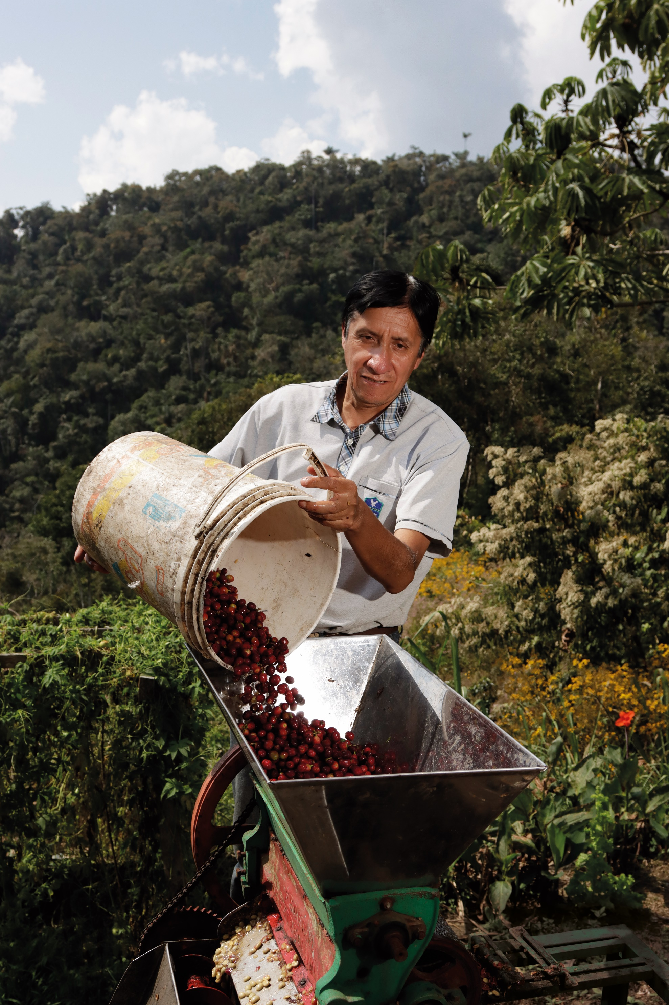

Overview from Fairtrade Canada

Fairtrade Coffee Price update for August 1, 2023

**Summary**

Fairtrade International recently announced that it will change the price structure for Fairtrade coffee in order to strengthen protections for coffee farmers around the world amid the intensifying impacts of climate change and growing global economic volatility.  These increases will provide farmers with significant price risk management support in times of considerable market fluctuation and aid them in adapting to their needs as they face inflation in their home countries and substantial additional costs due to climate change adaption.

**What does this mean for me as a retailer?**

These changes come into effect from August 1, 2023, and relate to the price that Fairtrade certified coffee roasters or importers pay to farmer cooperatives at FOB to purchase Fairtrade green coffee. This applies whether they buy directly from Fairtrade coffee producers, or via an intermediary supplier.

How this will impact your Fairtrade coffee vendors will vary greatly depending on the type, quality, and specific country origins they source from. It is likely that **vendors who supply you with Fairtrade coffee may have an increased cost of goods,** depending on the movement of the Commodities market and of the type and quality of Fairtrade coffee they source and sell to you.

**How does Fairtrade coffee pricing work?**

Coffee is a commodity priced on the commodities market, typically known as the NYC “C-Market price.” The Fairtrade Minimum Price acts as a floor price for Fairtrade coffee, a safety net that kicks in when the C-Market price falls below the Fairtrade Minimum Price.

The new Fairtrade Minimum Price, aka floor price for Arabica washed coffee has been increased by $0.40 US per pound and will now be $1.80 US per pound.

From mid-April to mid-May 2023, the C-Market price has fluctuated between a high of $2.05 US per pound and $1.83 US per pound. As the market price is higher, the Fairtrade floor price would not kick in over this period. Should the C-Market price fall below the $1.80 US per pound floor price, then the Fairtrade Minimum Price will kick in.

In addition to the above, Fairtrade defines a Fairtrade Premium and, if relevant, an organic differential. These premiums are added to the C-Market price or the Fairtrade Minimum Price, whichever is higher. Please note that any prevailing country or quality differentials are then added on top.

The Fairtrade Premium remains the same at $0.20 US per pound. The organic differential will increase from $0.30 US per pound to $0.40 US per pound.

For more information on Fairtrade and Fairtrade pricing please see the FAQ section.

**Small Coffee Farmers need our support, more than ever.**

Canada has become one of the top 3 consuming countries for Fairtrade coffee globally. Your business decision to support and sell Fairtrade coffee has a significant impact on coffee communities in the Global South. We want to express our gratitude for your continuous support for Fairtrade. What farmers emphasized to us is that they absolutely need this Fairtrade Minimum Price increase, because they simply cannot afford to continue farming with prices that consistently fail to cover their real costs.

**FAQ**

**What is the Fairtrade Minimum Price?**

Amodel unique to Fairtrade, the Fairtrade Minimum Price is the minimum that producers are paid when selling their products through Fairtrade. It aims to cover the average costs of sustainably producing a crop and acts as a safety net when market prices drop. When C-Market prices are higher than the Fairtrade Minimum Price, Fairtrade coffee producers must be paid the higher of these 2 prices.

Since the introduction of the Fairtrade label in November 1988, the New York C-Market price has been above the previous Fairtrade Minimum Price of $1.40 US per pound only 26% of the time. 32% of the time the price was far below 100 cents.

**This graph comparing the C-Market price and Fairtrade Minimum Price and Premium demonstrates the uniqueness of the Fairtrade model and how the Fairtrade Minimum Price works.**

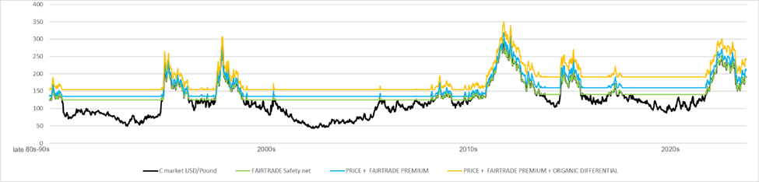

**The Fairtrade Minimum Price has protected producers from at times very severe price crisis for 25 of the past 34 years. Without the Fairtrade Minimum Price, many coffee farmers wouldn’t have been able to survive.**

**What is the new Fairtrade Minimum Price?**

The new Fairtrade Minimum Price for washed Arabica beans is $1.80 US per pound, an increase of $0.40 US over the previous price of $1.40 US per pound. For natural Robusta, the price will increase by $0.19 US to $1.20 US per pound.

**What is the Fairtrade Premium?**

On top of a Fairtrade Minimum Price, the Fairtrade approach includes a Fairtrade Premium – an additional sum of money that farmers invest in projects they choose. Investments of the Fairtrade Premium often target needed improvements in the community, or training and resources to enhance their businesses and operations. The Fairtrade Premium will remain at its current price of $0.20 US per pound.

**What is the Organic Differential?**

If the coffee is organic, an additional differential is paid to cover the higher cost of organic production. The additional value for organic Fairtrade coffee will increase from the current rate of $0.30 US per pound to $0.40 US per pound as of August 1, 2023.

**Updated Pricing**

|  |  |  |  |  |  |  |  |
| --- | --- | --- | --- | --- | --- | --- | --- |
|  | **Current prices since April 2011** | | |  | **New prices from 1st Aug, 2023** | | |
|  | **Fairtrade Minimum Price ($/lb)** | **Fairtrade Premium ($/lb)** | **Organic Differential ($/lb)** |  | **Fairtrade Minimum Price ($/lb)** | **Fairtrade Premium ($/lb)** | **Organic Differential ($/lb)** |
| Arabica Natural | $1.35 | $       0.20 | $          0.30 |  | C:\Users\Pippa\AppData\Local\Microsoft\Windows\INetCache\Content.MSO\D489B248.tmp$     1.75 | C:\Users\Pippa\AppData\Local\Microsoft\Windows\INetCache\Content.MSO\42D1F796.tmp$     0.20 | C:\Users\Pippa\AppData\Local\Microsoft\Windows\INetCache\Content.MSO\347FC014.tmp$         0.40 |
| Arabica Washed | $1.40 | $       0.20 | $          0.30 |  | C:\Users\Pippa\AppData\Local\Microsoft\Windows\INetCache\Content.MSO\61D66342.tmp$     1.80 | C:\Users\Pippa\AppData\Local\Microsoft\Windows\INetCache\Content.MSO\46BCA4A0.tmp$     0.20 | C:\Users\Pippa\AppData\Local\Microsoft\Windows\INetCache\Content.MSO\E0CB93AE.tmp$         0.40 |
| Robusta Natural | $1.01 | $       0.20 | $          0.30 |  | C:\Users\Pippa\AppData\Local\Microsoft\Windows\INetCache\Content.MSO\7FA06BEC.tmp$     1.20 | C:\Users\Pippa\AppData\Local\Microsoft\Windows\INetCache\Content.MSO\B76974DA.tmp$     0.20 | C:\Users\Pippa\AppData\Local\Microsoft\Windows\INetCache\Content.MSO\2065E1F8.tmp$         0.40 |
| Robusta Washed | $1.05 | $       0.20 | $          0.30 |  | C:\Users\Pippa\AppData\Local\Microsoft\Windows\INetCache\Content.MSO\B6D0B2C6.tmp$     1.25 | C:\Users\Pippa\AppData\Local\Microsoft\Windows\INetCache\Content.MSO\956E92C4.tmp$     0.20 | C:\Users\Pippa\AppData\Local\Microsoft\Windows\INetCache\Content.MSO\19B6B972.tmp$         0.40 |
|  |  |  |  |  |  |  |  |
| When including the various price elements, the old FOB minimum for Fairtrade coffee was $1.60 US/lb and FTO $1.90 US/lb | | | | | | | |
| As of August 1, 2023, the new FOB minimum for Fairtrade coffee will be $2.00 US/lb and FTO $2.40 US/lb | | | | | | | |

**How was the Fairtrade Minimum Price calculated?**

Fairtrade conducted a thorough cost of production analysis in 2022, based on 2021 harvest costs, across 12 origins and calculated the **average cost of production** for each country.  In addition, the specific context for organic certified farmers, who may face even higher labour costs and other increased costs to comply with organic standards, was considered.

Costs of production in some origins are significantly higher than in others. For example, in Honduras it is $2.00 US/lb and in Mexico $2.21 US/lb. While the new $1.80 US/lb Fairtrade Minimum Price does not cover the cost of production for all countries, it does so for at least 3 Fairtrade origins: Colombia, Nicaragua, Uganda.

**Who was consulted?**

In total, more than 540 participants - 469 producer organizations and 65 traders/roasters from 40 countries - gave input through a consultation process that Fairtrade International conducted between December 2022 and February 2023. Based on their feedback, Fairtrade presented a proposal to the Fairtrade Standards Committee on March 24, 2023 for its decision.

**Implementation Date**

All contracts buying coffee from coffee cooperatives signed on or after the August 1, 2023 date will need to be compliant in order to be Fairtrade certified. Contracts signed with producers before August 1for delivery post August 1 will be audited against the current prices.

**This is a pivotal moment in the coffee industry. Your continued partnership in the collective effort to support small scale coffee farmers is paramount to making it happen.**

*Further information on the cost of production studies and the Fairtrade coffee pricing is available upon request.*